**Phase 3: Implementation of Project**

**Name**: Lourdhu Priscilla A

**Reg No**: 311623244013

**College Name**: Misrimal Navajee Munoth Jain Engineering College

**College code**: 3116

**Department** : Computer Science And Business Systems

**Title: AI-Driven Natural Disaster Prediction &Management System**

**Overview**

**The goal of Phase 3 is to implement the core components of the Cyclone/Storm Prediction and Management System based on the plans and innovative solutions developed during Phase 2.**

**1. Interactive Storm Tracker**

**- Overview:** Create an interactive map that displays predicted cyclone/storm paths, allowing users to zoom in and out, view affected areas, and get real-time updates.

**- Implementation:**

- Integrate with weather APIs

- Use mapping libraries to display the map.

- Implement zooming, panning, and real-time update features**.**

**- Outcomes:**

**-** Users can visualize predicted cyclone/storm paths and plan accordingly.

- Users can view affected areas and take necessary precautions**.**

**2. Personalized Alerts**

**- Overview:** Offer users personalized alerts for specific locations, sending visual notifications when a cyclone/storm is predicted to affect their area.

**- Implementation:**

**-** Use notification services to send visual notifications.

- Integrate with weather APIs to trigger alerts based on predicted weather conditions

**- Outcomes:**

**-** Users receive timely and relevant alerts for their specified locations.

- Users can take necessary precautions and stay safe during cyclone/storm events.

**3. IoT enabled Proactive Tree Trimming**

**- Overview:** Provide insights and recommendations for proactive tree trimming to prevent roadblocks and power outages.

**- Implementation:**

**-** Integrate with IoT devices to gather data.

- Use machine learning algorithms to analyze data and predict potential tree failures.

- Display insights and recommendations on the website or mobile app.

**- Outcomes:**

**-** Authorities can proactively trim trees to prevent roadblocks and power outages.

- Reduced risk of accidents and disruptions during cyclone/storm events.

**4. Evacuation Ticket Booking**

**- Overview:** Allow users to book evacuation tickets or transportation services to safe zones**.**

**- Implementation:**

**-** Integrate with payment gateways (e.g., Stripe) to facilitate ticket booking.

- Use APIs to fetch evacuation routes and schedules.

- Display booking options and allow users to book tickets.

**- Outcomes:**

**-** Users can safely evacuate to designated safe zones.

- Reduced risk of casualties during cyclone/storm event**s.**

**5. Community Forum and Resource Hub**

**- Overview:** Create a community forum where users can share information and get support during cyclone/storm events. Additionally, provide a resource hub with links to emergency services, government websites, and other relevant resources**.**

**- Implementation:**

**-** Develop a forum platform (e.g., Discourse) for users to share information and discuss cyclone/storm-related topics.

**-** Curate links to emergency services, government websites, and other relevant resources.

- Display resources on the website or mobile app.

**- Outcomes:**

**-** Users can share information and get support from the community.

- Users have access to relevant resources and emergency services during cyclone/storm events.

**Challenges and Solutions**

**1. Model Accuracy**

**- Challenge:** The AI model may not accurately predict cyclone/storm paths or intensity due to limited training data or complex weather patterns.

**- Solution:** Continuous model refinement through feedback loops, regular testing, and updating with new data will improve accuracy over time.

**2. User Experience**

**- Challenge**: The interactive map and alert system may require refinement to make it more intuitive and user-friendly**.**

**- Solution:** User feedback during testing will be used to iterate and improve the design, ensuring an optimal user experience**.**

**3. IoT Device Integration**

**- Challenge:** Limited availability or connectivity issues with IoT devices (e.g., tree health monitoring sensors) may impact system performance.

**- Solution**: Simulations using sample data can demonstrate the system’s capability to handle real-time data, and contingency plans can be developed for device-related issues**.**

**4. Alert System Reliability**

**- Challenge:** The alert system may not function correctly during critical situations, leading to delayed or missed notifications.

**- Solution:** Redundancy and fail-safes will be built into the alert system, with regular testing and maintenance to ensure reliability.

**Outcomes of Phase 3**

**1. Functional Storm Prediction Model:** The AI model should be able to predict cyclone/storm paths and intensity with reasonable accuracy, providing relevant alerts and recommendations to users.

**2. Interactive Map and Alert System:** A user-friendly interactive map will be available, displaying predicted cyclone/storm paths and allowing users to set up personalized alerts.

**3. IoT Integration for Tree Trimming:** If IoT devices (e.g., tree health monitoring sensors) are available, the system will be able to gather data and provide insights for proactive tree trimming.

**4. Initial Testing and Feedback:** Feedback from early users will be gathered to identify areas for improvement and inform future development phases.

**Next Steps for Phase 4**

**In Phase 4, the team will focus on:**

1**. Improving Model Accuracy:** Refining the AI model using feedback and results from testing to enhance prediction accuracy and reliability.

2**. Enhancing** User Experience: Expanding features and functionality to improve user engagement, such as adding more detailed storm surge predictions or evacuation route planning.

3. **Scaling and Optimizing**: Optimizing the system to handle increased traffic, larger amounts of data, and more complex queries, ensuring high performance and reliability.

4. **IoT Integration**: Further integrating IoT devices to gather more detailed data on tree health, infrastructure, and other relevant factors, enhancing the system's predictive capabilities**.**

**Screenshots for code and progress:**



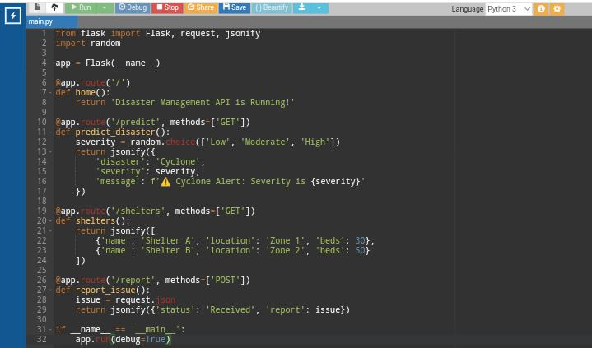

**Output:**

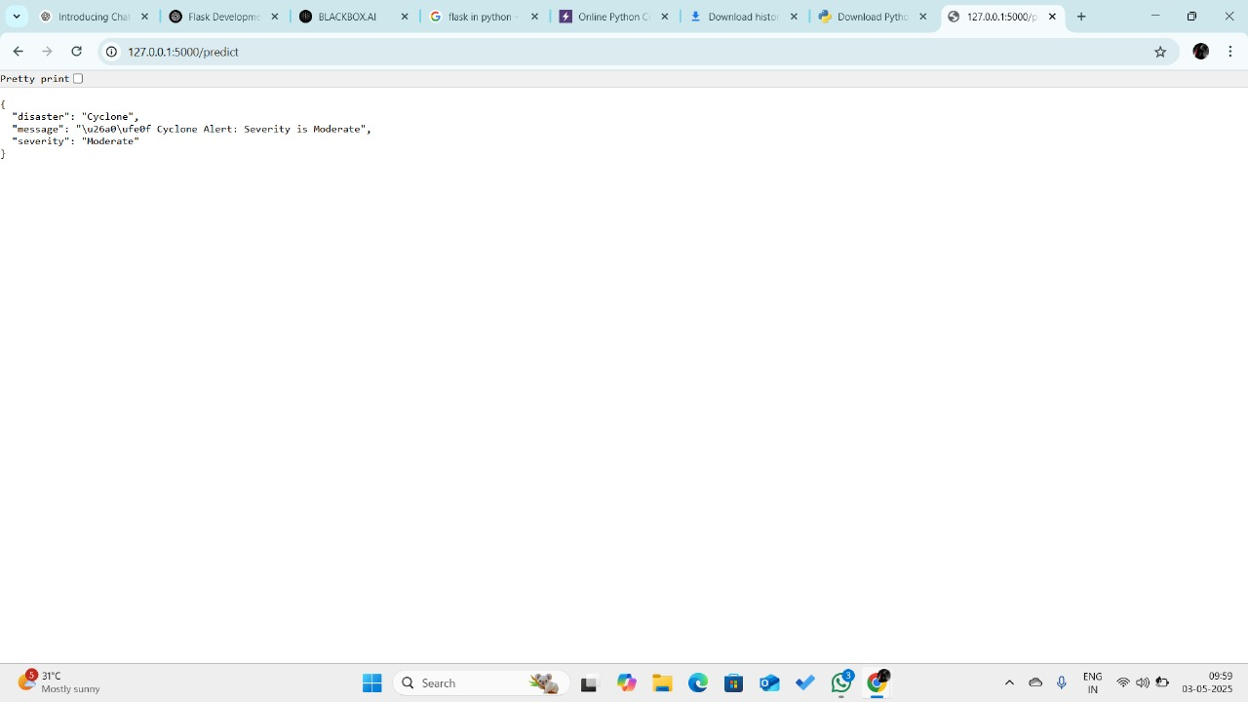

**TEAM MEMBERS:**

1. Nivethitha P(311623244016)
2. Thivahar J(311623244022)
3. Kanagavel(311623244011)
4. Karthikeyan B(311623244012)